CENG3420 Lab3 Report

Name: Lee Kong Yau

ID: 1155149600

This report is about the objectives of lab3 and show the machine result.

The program of lab 3 depends on the value in uop. Each digit will determent which gate should be open to bus, the output of mux, and to write or read memory etc.

First program is Swap.bin.The objective of Swap.bin is to swap two memory addresses’ data. At first, the original memory content is that 0x34 stores “0xabcd”, and 0x38 stores “0x1234”. The others are the machine code of swap program.

After running the machine code, t0 stores the data in original memory[0x34] and t1 stores the data in original memory[0x38],t2 and t3 stores the memory address respectively.

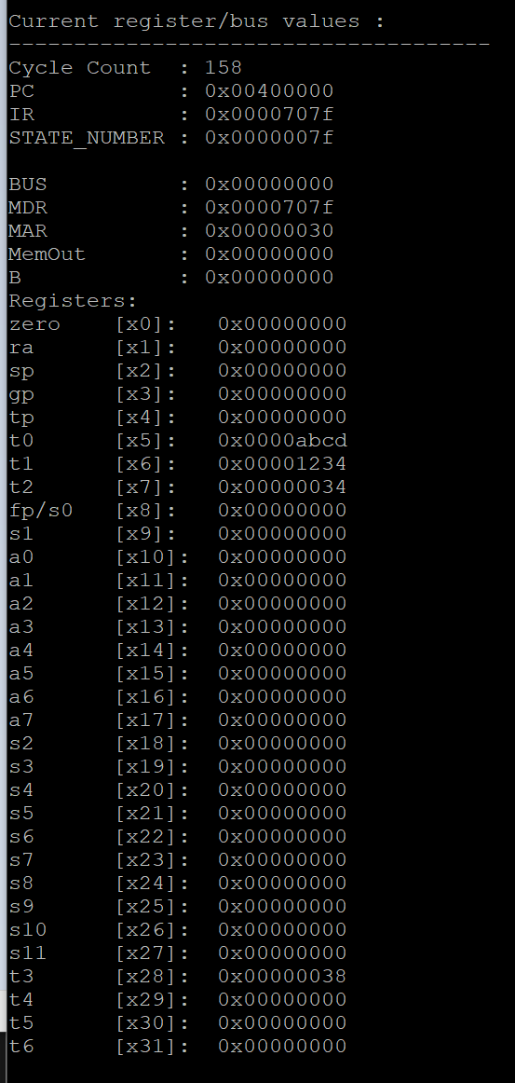

Also, after running the machine code, it swapped the data in memory[0x34] and memory[0x38].memory[0x34] stores “0x1234”, and memory[0x38] stores “0xabcd”.

Second program is Count10.bin. The objective of count10.bin is to let register t2[x7] count up with the number stores in register t1[x6], at the end each loop will decrease t1 by 1 and then will start a new loop unless t1 equals 0. The original register t1[x6] stores 55( 0xa)

After the first loop, register t1 and t2 store number as picture shown:

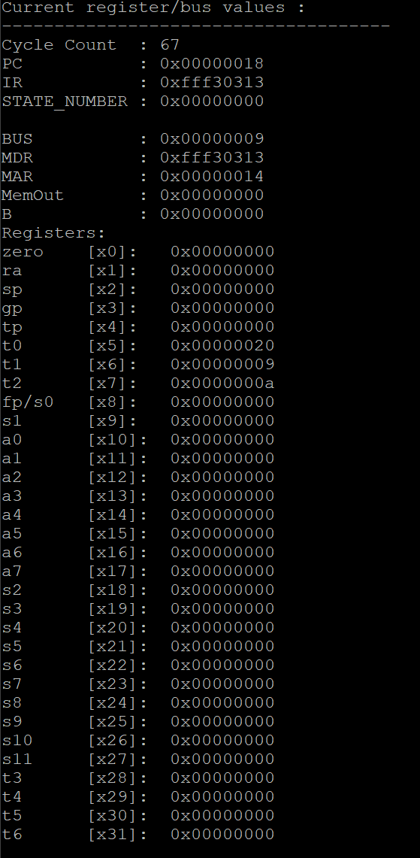

Finally, register t1 and t2 will store 0 and 55(0x37), respectively.

Third one is isa.bin. The original content in memory[0x0] to[0x84] are:

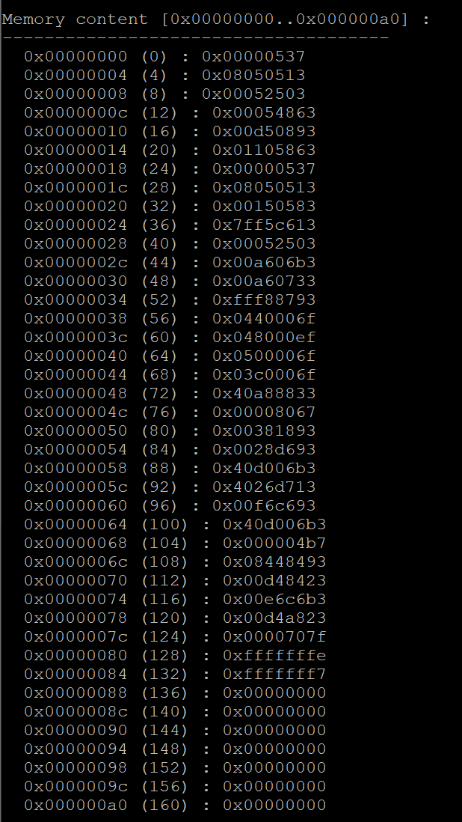

After “la a0”, and “lw a0, 0(a0)” .a0 will store -2 (0xfffffffe)

After “blt a0, zero, L1” and “addi a7, a0, 13”, a7 will store 11 (0x0000000b)

Finally, a0 to a7 store -2, -1,-2048,23,-7,10, 13,52 respectively.

And also, after running the program, the value in memory[0x8c] is 0x17, and memory[0x94] is 0xffffffee.

